Solving Systems of Equations Test

FORMULAS:
$y=mx+b$
m= slope
b= y-intercept
$$slope=\frac{rise}{run}$$

- Solve this system of Equations by graphing

y = x + 2 m=

y-intercept = (0,____)

y = -x – 2 m=

y-intercept = (0,____)

What is the solution? ____________
(Hint: The point where the 2 lines intersect.)

- Solve by graphing.

y = x – 5 m=

y-intercept = (0,____)

$$\frac{2}{5}x+y=4$$
HINT:
First, put into y-intercept form
$$y=mx+b$$

m=

y-intercept = (0,____)

What is the solution? ___________
(Hint: The point where the 2 lines intersect.)
Solve the following systems of equations using substitution.

- y = x – 6
x = - 2

First, substitute the value of x into the equation on top and solve for y.
When you have found y, use your answer with the given value for x to write the ordered pair (x,y).

4) y = x – 4

y = 2
First, substitute the value of x into the equation on top and solve for y.
When you have found y, use your answer with the given value for x to write the ordered pair (x,y).

Solve the following systems of equations using elimination
(Hint: same number, different sign)

5) -x + y = 8
x + 2y = 7

6) x – y = -6
X + y = 8

7)
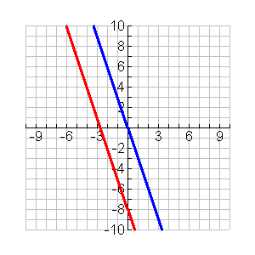
Solution:____________________________

8)

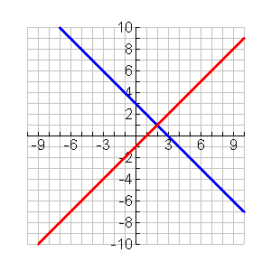

Solution:____________________________

